RAG-Based AI Chatbot - Developer Documentation

Introduction
This documentation provides a step-by-step guide to understanding and working with the RAG-based AI chatbot. The chatbot retrieves relevant documents using ChromaDB and generates responses using the Mistral-7B model.

1. Project Overview
This chatbot follows the Retrieval-Augmented Generation (RAG) approach, which combines document retrieval and AI-generated responses.

Core Features:
- Document Processing: Extracts text from PDFs, Word documents, and Markdown files.
- Vector Storage: Stores document embeddings using ChromaDB.
- Retrieval System: Fetches the most relevant document chunks based on user queries.
- AI Response Generation: Uses Mistral-7B to generate context-aware responses.
- FastAPI Backend: Exposes an API for chatbot interactions.
- Streamlit Frontend: Provides a user-friendly chatbot interface.

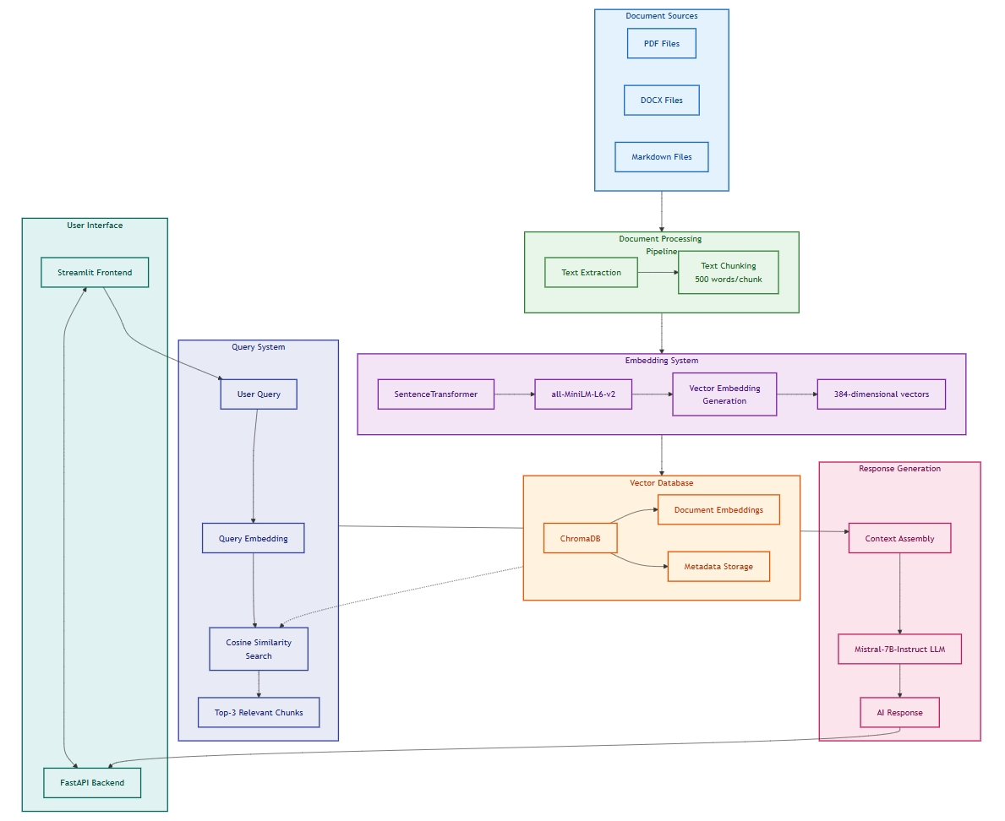

2. Setup Instructions

2.1 Requirements Installation
Ensure you have Python installed (preferably Python 3.8+). Install dependencies using:
pip install -r requirements.txt

2.2 Download the Embedding Model
Run the script to download the Mistral-7B-Instruct-v0.1-GGUF.
!huggingface-cli download TheBloke/Mistral-7B-Instruct-v0.1-GGUF mistral-7b-instruct-v0.1.Q4_K_M.gguf --local-dir ./models --local-dir-use-symlinks False

2.3 Download the Embedding Model
Run the script to download the MiniLM model:
python download_model_minilm.py
This script fetches the all-MiniLM-L6-v2 model and caches it locally.

2.4 Run the Document_processor:
!python document_processor.py
This will process the documents and store chunks and embeddings.

2.4 Run the Retrieval:
This retrieves the embeddings.

!python retrieval.py
#please enter "exit" in it.
This will start an API server at http://localhost:8000.

2.4 Run to login into Hugging face:
from huggingface_hub import login

#write here your hugging face token
# you can use this link to get more information https://huggingface.co/docs/hub/security-tokens
# please create a " write " token
huggingface_token = "hf_xxxxxxxxxxxxxxxxxxxxxxx"
login(token=huggingface_token)

print("successfully logged in to hugging face")

2.4 Run to Generate responses from LLM:
!python response_generator.py

2.4 Run the Backend
Start the FastAPI backend by running:
uvicorn test_backend:app --host 0.0.0.0 --port 8000
This will start an API server at http://localhost:8000.

2.5 Run the Frontend
Launch the Streamlit UI using:
streamlit run test_frontend.py

3. Code Breakdown

3.1 Document Processing (document_processor.py)
This module handles document ingestion, text extraction, and vector storage.
- extract_text_from_pdf() - Reads text from a PDF file.
- extract_text_from_word() - Reads text from a DOCX file.
- chunk_text() - Splits text into smaller chunks.
- store_in_vector_db() - Generates embeddings and stores them in ChromaDB.

3.2 Retrieval Module (retrieval.py)
- search_documents(query, top_k=3) - Searches for the top K relevant document chunks in ChromaDB.

3.3 Response Generation (response_generator.py)
- generate_response(prompt, context) - Generates an AI response using Mistral-7B.
- select_best_context(query, retrieved_chunks) - Chooses the most relevant document chunk.

3.4 FastAPI Backend (test_backend.py)
- /query/ API endpoint processes user queries and returns AI-generated responses.

3.5 Streamlit Frontend (test_frontend.py)
- Displays a chat interface.
- Calls the FastAPI backend to retrieve responses.

4. How it Works

Step 1: Document Processing
- Documents are processed and stored in ChromaDB.
- Text is chunked, and embeddings are generated.

Step 2: Query Handling
- The user enters a query.
- The backend searches the most relevant document chunks.
- The best-matching context is selected.

Step 3: Response Generation
- Mistral-7B generates a response based on the retrieved context.
- The response is sent to the user.

